Al-Anon
District 12
San Antonio
Al-Anon Information
Service Office

Events – Contacts – Addresses – Minutes Fall Edition 2024
Addresses and contact information contained in this publication are for Al-Anon business
only and should not be used to promote any outside enterprise.

UPCOMING EVENTS

District
Representative’s

Corner


DISTRICT REPRESENTATIVE REPORT

We had a frightfully good time at the district meeting on October 19 at the Bulverde United Methodist Church. There were no ghosts or goblins but there was a witch, a bat, a butterfly and even the Lone Ranger! We had fun, food and fellowship but also had to get down to business.

The Fall Assembly will finally be here in November, and we have been working with District 13 to get the final details worked out. As support district we are responsible for the Friday night activities. A big thank you to all of you who are willing to step up your service and help out with the Friday night workshop. As for the business meeting of the Assembly we already have several items up for vote, I am hoping there won’t be much discussion with those, and we can get more accomplished at this assembly.

This is a great opportunity for those who are curious about service at the area level – the assembly is taking place right up I10 in Kerrville. Anyone can attend but only Group Representatives can vote. Also, this assembly will be a great opportunity if you know any teens who need or are interested in our program of Alateen. Check the saais12.com website in early November for all issues related to Assembly.

I am thrilled to announce we have elected a new Public Outreach Coordinator! Mike B. was elected by unanimous vote. He officially starts in 2025 but has already attended some meetings with the Area Public Outreach Coordinator. He will finish out the Panel 64 term and have the option to continue into the next. Look for his complete bio on the saais12.com website.

DR’s REPORT (CONTINUED Pg. 3)

--- continued on page 3 ---

November 8-10, 2024 | ETAAA Fall Assembly  Inn of the Hills Hotel  1001 Junction Highway  Kerrville, Texas 75028
January 25, 2025 | AWSC meeting  (Hosting)
FEBRUARY 1, 2025 | DISTRICT 12 MEETING  CLUB 12 AL-ANON ROOM
Feb 21-23, 2025 | All Texas Al-anon Alateen Conference (ATAAC)  Richardson, Texas

Al-Anon Information Service
Officers and Coordinators

2024 – 2026 District 12

Officers and Coordinators

Boerne Hope AFG  Janice A. | Courage To Change AFG  Dolores W.
Saturday Big Book AFG  Cheryl W. | Northwest San Antonio AFG  Irma M.
G
Gold Canyon AFG  Donna B. | Sunrise AFG  Karen V.
Pass It On AFG  Lynn Starkey | Seguin Serenity AFG  Renee S.

Group Representatives/Alternates
attending district meeting 07/13/2024

SAAIS Chair  Tony Almedia | Cell 214-724-5937  Avalmedia71@outlook.com
SAAIS Secretary | OPEN
SAAIS Treasurer | Cell-210-394-6944  tglazener@satx.rr.com
SAAIS Website Coordinator  Lynn Starkey | Cell 210-269-6664  Amias200387@yahoo.com
SAAIS Speaker Mtg Coordinator  Rosie Miranda | Cell 210-279-4164  Simpsonfan91@gmail.com
SAAIS Liasion to AWSC  Candy Neal | Cell 210-846-0877  cneal@nealtx.com
SAAIS Phone Service  Lucy Reina  Al-Anon Bookstore at Club 12-Pat Estus | Cell 210-434-8012  lucyreina@sbcglobal.net  Cell 210-342-3063  Group12afg@att.net

District Representative  Patti Watson | Cell 281-904-1951  Txedistrict12@gmail.com
Alternate District Representative  Janice Almeida | Cell 469-263-6025  Janice.maggie1@gmail.com
Secretary  Marc Braunam | Cell 210-677-5169  mbraunam@netzero.net
Treasurer  Trina Martin | Cell 830-660-3083  tlyngermino@yahoo.com
Alateen Coordinator  Lynn Starkey | Cell 210-269-6664  Amias200387@yahoo.com
Literature Coordinator  Renee Sanders | Cell 512-731-3091  rsanders@nbisd.org
Spanish Coordinator  Rosie Miranda | Cell 210-279-4164  Simpsonfan91@gmail.com
Al-Anews Coordinator  Rene Dymale | Cell 830-463-2850  District12alanews@yahoo.com
Travel Coordinator  Karen Valdez | Cell 210-710-9704  Snowbird.karen@gmail.com
Public Outreach Coordinator | Open
Archives Coordinator | Open

San Antonio Al-Anon Information Service
 800-800-7008

Please respect our traditions!
Addresses and contact information contained in this publication are for Al-Anon business only

and should not be used to promote any outside enterprise
DR’s Report (Continued from Page 1)

We are participating at AA in SA, the annual conference for Alcoholics Anonymous held in the Shriners Auditorium on Loop 1604 near Stone Oak. We will have a table with literature set up and be there to answer questions. We participate every year but since this is the new term I was contacted a little late so was not able to notify the district. Hopefully next year we will be better prepared.

We agreed at the district meeting to hold A Day in Al-Anon this year. Lynn S has agreed to chair, she has some wonderful initial ideas for the day. Several have already stepped up to be on committees. It can’t happen unless everyone wants and participates, and everyone agreed that we can do it!

We will be pushing out of our comfort zone for the First District Meeting of 2025. A totally different itinerary. February 1 we will be meeting at Club 12 Al-Anon meeting room at 3:00 PM. At 5:00 we will dismiss for a potluck dinner with everyone bringing a favorite dish. At 7:00 we can attend the speaker meeting taking place that weekend. All we ask is you purchase a drink at the Club 12 concession stand. They better stock a lot of tea that day!

We talked about some other possible locations for upcoming district meetings more in central San Antonio. We can always utilize the district zoom account if there is not much to discuss but I do like meeting face to face better. It gives us a better chance to connect. And that, after all, is what this fellowship is all about, breaking our isolation, connecting with others and having a life of purpose on my own.

Thank you all for your service to Al-Anon. I hope to see you in Kerrville, it’s gonna be great!

Patti Watson

DISTRICT 12 MEETING MINUTES

Patti W. opened the District 12 Quarterly Business Meeting on Oct 19, 2024, at 10:15 am with the Serenity Prayer. The Twelve Traditions and Twelve Concepts of Service were read. The meeting took place at the Schertz United Methodist Church, 3460 Roy Richard Drive, San Antonio, Texas 78154 .
Roll Call-Karen V. Voting Members: 8 | ⅔ Majority: 5; 51% Majority: 5
Approval of Minutes-Patti W. The July 13, 2024 minutes were published in the 3rd Quarter 2024 edition AL-ANEWS. There were no corrections, the minutes were approved as published.

Lynn S. requested that the minutes be posted on the District Website.
Lynn S. requested that the minutes be posted on the District Website.
Reports:
Treasurer’s Report-Trina M.
Trina reported a net change of +$130.42. Contributions totaled $442.72 and expenses totaled $312.30. As of September 30, 2024 the checking account balance was $8475.63 and the savings account balance was $2634.67.
Trina offered WSO remittance slips to anyone whose group would like to send a contribution to WSO. She reminded groups who use bank generated checks to update the mailing address to the new treasurer. Our district budgeted to donate $100 each to WSO and Area. Trina encouraged us to send in any 4th quarter contributions early enough in December so they can be counted toward this calendar year’s income.
Audits of financial records from 2021, 2022, 2023 were completed by Trina M, Candy N, and Tony A. There were no material findings.

NO REPORT
ALTERNATE DISTRICT
REPRESENTATIVE REPORT

ALATEEN REPORT

In keeping with my District Alateen Coordinator job description:
“To visit all Alateen Groups in the District” on September 21 I visited the Just for Today Alateen group in San Antonio and September 23 I visited the Boerne Hope Alateen group in Boerne.

My purpose was to meet the Alateen group sponsors and of course the Alateens. Next was to share my role as the District 12 Alateen Coordinator (DAC) by encouraging the groups to have a Group Representative (GR) and attend the district and area meetings, explaining their attendance gives their group a voice and a vote at both of these meetings.

I made packets of handouts for each group. One was a GR packet and one was a packet to register for the Fall Assembly in Kerrville. I shared with the Alateens the plan for Alateen participation at the Fall Assembly of an Alateen panel for the Sunday morning program.

I sent an email to the Area Alateen Coordinator requesting that an email be sent to the other District Alateen Coordinators asking them to encourage their Alateen groups to share the information about the assembly and the need for Alateens to participate in all of the events of weekend.

I have had 3 inquiries to become an Al-Anon Member Involved in Alateen Service in this next year. I will be setting up an initial training workshop the first of 2025. If you are curious about Alateen group sponsorship please feel free to call and let’s talk.

In Alateen Service,
Lynn

‘TOGETHER WE CAN MAKE IT” FOR A DAY IN AL-ANON

Looking ahead to April 26, 2025 I am asking for your thoughts and ideas for a day of Al-Anon with learning as well as fellowship.

One thing I learned from a long time member of Al-Anon was the definition of the word “workshop”. According to The Random House College Dictionary: a seminar, discussion group, or the like, which emphasizes exchange of ideas and the demonstration and application of techniques, skills, etc.

Here are some ideas I have come up with:
1. Your favorite piece of Conference Approved Literature (CAL) everyone brings one piece of CAL and share when, where and how you use it in your program of recovery.
2. Sponsorship – Personal and Service – How do you select and use this wonderful Al-Anon recovery tool.
3. Public Outreach – How To Do It I have heard over and over “How do we share this program to the outside community?”
4. Potluck Lunch – Everyone bring their favorite “potluck” dish and share your recipe. And have table topics during lunch.
5. What is your idea or ideas?

__________________________________________________
__________________________________________________
__________________________________________________

__________________________________________________

Lynn Starkey

PUBLIC OUTREACH COORDINATOR

Position Vacant

AL-ANEWS EDITOR REPORT

If you are interested in receiving our District 12 newsletter please include your Name, Group Name, Group Number and email address.
All groups in District 12 and 13 should be receiving the AL-ANEWS.
I do have some individual members that receive one too.
Deadline for the Winter 2024 issue of the AL-ANEWS is February 28, 2025.

Rene D.
AL-ANEWS Editor

ARCHIVE REPORT

ARCHIVES COORDINATOR

This Position is still Vacant. Please read the job description and think about how you might serve.
- To gather, organize and protect the documented history of the district.
- To encourage individual members to take photos and keep accounts of District functions and submit them to archives.
- To collect the history of groups in the district.
- To share archives ideas with the Groups in the District.
- To set up displays of archival materials at each District meeting.
- To solicit archival materials from groups within the District.

SPANISH COORDINATOR

No Report
Rosie M.
Spanish Coordinator

TRAVEL REPORT

NO REPORT

LITERATURE COORDINATOR

Greetings Everyone!

We have new literature! It is a 48 page booklet titled “Healing within Our Alcoholic Relationships-A Collection of Insights from Our Shared Journey” (P95).

This powerful collection shares brief nuggets of insight and inspiration mined from decades of member experience, adapted from The Dilemma of the Alcoholic Marriage and other Al-Anon literature on relationships. This ideal for newcomers or anyone who wants to get back to basics with some “Instant Al-non.

Available now on the Al-Anon Online Bookstore or a Literature Distribution Center near you! Available in English, Spanish, and French for only $4!

Can you believe that “A Little Time For Myself” is a year old? If you don’t have a copy yet, it is also available online or at your closest LDC. With the holidays coming up, it would make a great gift.

The Forum magazine is always looking for writings-please consider sharing your experience, strength, and hope. The Forum is also still a bargain at $11 for a yearly subscription. Each group deserves one and so do you!

Renee S.

SAAIS UPDATE

.

Committee Quarterly Meeting Minutes
Meeting via Zoom
October 13, 2024 @ 7 p.m.

We began @ 7 p.m. with a moment of silence, followed by the Serenity Prayer
  - Roll Call – Janice Almeida filling in for Secretary, Mike B.
  - 14 people attended – Voting 12, Not voting 2 2/3 = 8 and Majority - 7
Reports
  - Secretary’s Report – Minutes of July 13, 2024 meeting/attached – Minutes were approved as sent out prior to the meeting
  - Treasurer’s Report – Theresa G. – see attached – Treasurer’s Report was accepted
  - Zoom Account Utilization Report – Janice A., Coordinator
    - Reported we continue to use zoom once a month between AIS and District 12
  - Website update – Janice A. – website has been down due to issues but is back up and running. A question was asked if we are paying the Website consultant for his time to resolve the issues on the website. We reported at this time that we have not been asked for any additional funds but pointed out we have paid his invoice and also provided a gift card for his personal use as a gesture of gratitude and fairness.
  - SAAIS/AWSC Liaison Report – Candy N – reported nothing much accomplished at AWSC meeting but she was able to brag on our Serenity Celebration’s success
  - Monthly Speaker Meeting Coordinator Report – Rosie M. – everything going great – usually have a packed house
  - Answering service report - Lucy R. – continue to have minimal calls but she does respond to any emergency call right away
  - Website Coordination Service Report- Lynn S. – lists are up to date – she did remind us to let WSO know of any meetings we are not having that are on our regular posted schedule (ie. Halloween, Thanksgiving, Christmas, etc.)
  - 2024 Serenity Celebration recap and report – Candy Neal
    - Everything went extremely well
    - Thanks again to Dolores for the beautiful donation of decorations.

    - Would tweak a few things for next year but the changes we did this year were met with great enthusiasm (Auction/Silent Auction, Partner bidding flags, Early timeline)
    - Still need someone to lead the venue next year
    - We need someone to take charge, or it may not happen in 2025
    - We also voted to have the Treasurer to explore having a Venmo or Zelle option linked to our account
  - Service opportunities for a new panel of trusted servants:
    - Including: Chair, Secretary and Event Coordinator
    - (We are assuming the Treasurer and Liaison, Monthly Speaker Meeting Coordinator and Answering Service Coordinators are still in the current term and are not to be replaced at this time – please advise if that is not correct) .

New Business ?? no new business was presented

Old Business – any further thoughts?
  - Question: What should we do with the excess funds we hold in our keeping?
  - Suggestions were made to consider using some of the funds to support Alateen attending ATAAC, towards the next Al-Anon Convention in San Antonio or seed money to Serenity Celebration
    - Would suggest forming a Thought Force to gather ideas on how to best utilize money held by SAAIS to impact local needs in our community
    - Tony suggested we move forward with the Thought Force and the following people have volunteered to serve: Lynn S., Suzanne P. and Irma M.

We did set this date, but it was later established at the District 12 meeting:

Next meeting date, 2/1/25 at Club 12 – before or after the District 12 Meeting .

Close meeting with 7th Tradition and Al-Anon Declaration
Meeting ended @ __8:00 p.m.

Respectfully submitted,
Janice Almeida on behalf of Mike B., Secretary

DISTRICT 12- 2024 FINANCIAL REPORT
 | Q1 | Q2 | Q3 | Q4 | YTD | BUDGET |  | BUDGET vs ACTUAL
INCOME
Gratitude Baskets |  |  |  |  | 0.00 | 0 |  | 0
Group Contributions | 439.00 | 210.38 | 442.72 |  | 1,092.10 | 2,000 |  | 908
Misc Income |  |  |  |  | 0.00 | 100 |  | 100
Workshop |  |  |  |  | 0.00 | 0 |  | 0
TOTAL INCOME | $ 439.00 | $ 210.38 | $ 442.72 | $ - | $ 1,092.10 | $ 2,100 |  | 1,008
EXPENSES
Al-Anews Editor |  |  |  |  | 0.00 | 25 |  | 25
Alateen Coordinator |  | 135.32 |  |  | 135.32 | 250 |  | 115
Alternate District Rep |  |  |  |  | 0.00 | 25 |  | 25
Archives Coordinator |  |  |  |  | 0.00 | 0 |  | 0
District Representative |  | 256.44 | 312.30 |  | 568.74 | 1,200 |  | 631
Public Outreach Coordinator |  |  |  |  | 0.00 | 200 |  | 200
Secretary | 26.64 |  |  |  | 26.64 | 25 |  | (2)
Spanish Coordinator |  |  |  |  | 0.00 | 25 |  | 25
Treasurer | 34.48 |  |  |  | 34.48 | 50 |  | 16
Facility Rental |  | 50.00 |  |  | 50.00 | 0 |  | (50)
Gratitude Baskets |  |  |  |  | 0.00 | 0 |  | 0
Area Delegate Visit |  |  |  |  | 0.00 | 0 |  | 0
WSO Contribution |  |  |  |  | 0.00 | 100 |  | 100
Area Contribution |  |  |  |  | 0.00 | 100 |  | 100
Workshop |  |  |  |  | 0.00 | 0 |  | 0
Misc |  | 84.27 |  |  | 84.27 | 100 |  | 16
TOTAL EXPENSES | $ 61.12 | $ 526.03 | $ 312.30 | $ - | $ 899.45 | $ 2,100 |  | 1,201
Bank Register Summary
Begin Bal - Checking | 8,282.98 | 8,660.86 | 8,345.21 | 8,475.63
Income (from above) | 439.00 | 210.38 | 442.72 | 0.00
Expenses (from above) | (61.12) | (526.03) | (312.30) | 0.00
Net Change for Period | 377.88 | (315.65) | 0.00 | 0.00
Transfer to Savings
End of Period Balance | 8,660.86 | 8,345.21 | 8,475.63 | 8,475.63
Begin Bal - Savings (Ample  Reserve) | 2,624.84 | 2,628.10 | 2,631.37 | 2,634.67
Interest | 3.26 | 3.27 | 3.30
Deposits
End of Period Balance - Savings | 2,628.10 | 2,631.37 | 2,634.67 | 2,634.67
Total Ending Cash Balance | 11,288.96 | $ 10,621.46 | $ 10,983.26 | $ 10,907.82

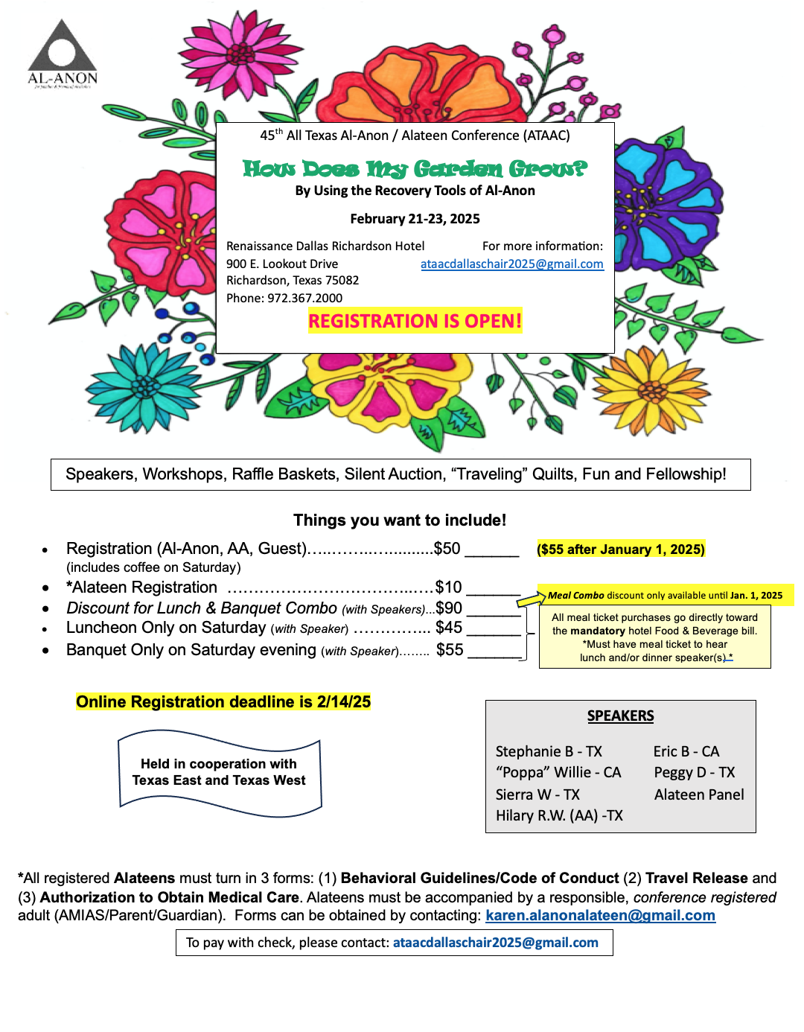

GROUP CONTRIBUTIONS

GROUP NAME | GROUP # | JAN | FEB | MAR | APR | MAY | JUN | JUL | AUG | SEP | OCT
Hoola Hoop | 30773087 |  |  |  |  |  |  |  | 150.00
Sunset Group | 66576 |  | 30.00
Stepping Thru Life | 30603027 |  | 135.00 |  |  |  |  |  |  | 50.00
Gold Canyon | 30649422 |  | 30.00 |  |  |  | 30.00 |  | 30.00
Recovery in Gruene | 30682563
Boerne AFG | 54752 |  | 50.00 |  |  |  |  |  |  | 100.00
Wed 1:00 PM | 30534037 |  | 26.25 |  |  |  |  |  |  | 43.12
Courage to Change | 30603560
Serenity & Hope | 30622446
NW SA AFG | 30567383
Seguin Serenity | 13520
Pass it On | 62395
NE San Antonio Parents | 30567146 |  | 50.00
Seguin AFG | 26539 |  | 50.00 |  |  |  | 50.00
Happy Hour AFG | 30693766 |  | 67.75 |  |  |  | 34.00
Cathedral Park | 66248 |  |  |  | 34.13 |  | 62.25 |  | 9.60
Sunrise AFG | 30661525
Solo Por Hoy | 500757 |  |  |  |  |  |  |  |  | 60.00
Canyon Lake AFG | 30664350
TOTAL |  | $ - | $ 439.00 | $ - | $34.13 | $ - | $ 176.25 | $ - | $ 189.60 | $ 253.12 | $ -

DISTRICT 12 CONTRIBUTION
Make Check Payable to: AFG District 12 Mail to: District Treasurer
420 N Milam St
Seguin, TX 78155
(address expires 12/31/2026)

Group Name _________________________________________________ Group # _________________

Current Mailing Address ________________________________________________________________

City/State/Zip______________________________________________ Telephone # ________________

Sent By ___________________________________ Check # _____________ Amount _____________

AL-ANON WORLD SERVICE OFFICE CONTRIBUTION

Make Check Payable to: AFG, Inc. Mail to: AFG, Inc.
1600 Corporate Landing Pkwy
Virginia Beach, VA 23454-5617

Group Name ________________________________________District # _______ Group # _________

Current Mailing Address ______________________________________________________________

City/State/Zip_______________________________________________Telephone # ______________

Sent By _________________________________ Check # ______________ Amount ______________
TEXAS EAST AREA 53 CONTRIBUTION
Make Check Payable to: ETAAA-Treasurer Mail to: ETAAA
Attach this form to check or money order. PO Box 337
Do not send cash. Please print information. Pearland, TX 77588
(address expires 12/31/2026)

Group Name__________________________________________ District# ________ Group #__________

Current Mailing Address ________________________________________________________________

City/State/Zip _________________________________________Telephone # _____________________

Sent By ___________________________________ Check # ______________ Amount _____________

Email (for receipt) _______________________________________________________________________

SAN ANTONIO AL-ANON INFORMATION SERVICE CONTRIBUTION
Make Check Payable to: SAAIS Mail to: SAAIS Treasurer
172 Fossil Hills Loop
Spring Branch, TX 78070
(address expires 12/31/2026)

Group Name _________________________________________District # _______ Group # _________

Current Mailing Address ________________________________________________________________

City/State/Zip_______________________________________________Telephone # ________________

Sent By ___________________________________Check # ______________ Amount ______________

