Al-Anon
District 12
San Antonio
Al-Anon Information
Service Office

Events – Contacts – Addresses – Minutes Summer Edition 2024
Addresses and contact information contained in this publication are for Al-Anon business
only and should not be used to promote any outside enterprise.

UPCOMING EVENTS

District
Representative’s

Corner


DISTRICT REPRESENTATIVE REPORT

As Concept Four states “Participation is the key to harmony” A great service opportunity was presented in June of 2024 for all Al-Anon members to participate in the Al-Anon Membership Survey. The survey is taken every three years by the World Service Office (WSO). The survey provides feedback helps to validate the effectiveness of the Al-Anon Family Group program and its recovery tools through data analysis. Participants remain completely anonymous, but the surveys are used to help improve clinical understanding for professionals to recommend Al-Anon as a resource for those affected by the family disease of alcoholism. The survey is way for us in Al-Anon to share what we already know – this program works if you work it. Another survey will be offered in three years for those who missed it this year.

Our quarterly district meeting was held on July 13 at the Schertz United Methodist Church. Thank you to Pass It On for reserving the Quad room for our meeting. Group Representatives turned in registration forms and money for the San Antonio Al-Anon Information Service’s (SAAIS) Serenity Celebration which is occurring September 8. Tickets can still be purchased online by going to the district website saais12.com or by seeing your Alternate Group Representative or Group Representative for more information.

We are the support district for the upcoming Fall Assembly in Kerrville hosted by District 13. We have been given the responsibility of hosting the Friday night program. The members attending the district meeting discussed and agreed that a panel of Alateens

DR’s REPORT (CONTINUED Pg. 3)

--- continued on page 3 ---

October 19, 2024  (subject to change) | District 12 Meeting  TBD
November 8-10, 2024 | ETAAA Fall Assembly  Inn of the Hills Hotel  1001 Junction Highway  Kerrville, Texas 75028
January 25, 2025 | AWSC meeting  (Hosting)
Feb 21-23, 2025 | All Texas Al-anon Alateen Conference (ATAAC)  Richardson, Texas

Al-Anon Information Service
Officers and Coordinators

2024 – 2026 District 12

Officers and Coordinators

Boerne Hope AFG  Janice A. | Serenity’s Path AFG  Sarah W.
Cathedral Park AFG  Trudi C. | Canyon Lake Solutions AFG  Audrey B.
G
Gold Canyon AFG  Donna B. | Northwest San Antonio AFG  Irma M.
Pass It On AFG  Lynn Starkey | Recovery In Gruene  Jill W.
Seguin Serenity AFG  Kate S. | Sunrise AFG  Kathy B.
Sunset AFG  Marc B. | Booster Shot AFG  Lucy R.
Just for Today ATN
Christian Vasquez

Group Representatives/Alternates
attending district meeting 07/13/2024

SAAIS Chair  Tony Almedia | Cell 214-724-5937  Avalmedia71@outlook.com
SAAIS Secretary | OPEN
SAAIS Treasurer | Cell-210-394-6944  tglazener@satx.rr.com
SAAIS Website Coordinator  Lynn Starkey | Cell 210-269-6664  Amias200387@yahoo.com
SAAIS Speaker Mtg Coordinator  Rosie Miranda | Cell 210-279-4164  Simpsonfan91@gmail.com
SAAIS Liasion to AWSC  Candy Neal | Cell 210-846-0877  cneal@nealtx.com
SAAIS Phone Service  Lucy Reina  Al-Anon Bookstore at Club 12-Pat Estus | Cell 210-434-8012  lucyreina@sbcglobal.net  Cell 210-342-3063  Group12afg@att.net

District Representative  Patti Watson | Cell 281-904-1951  Txedistrict12@gmail.com
Alternate District Representative  Janice Almeida | Cell 469-263-6025  Janice.maggie1@gmail.com
Secretary  Marc Braunam | Cell 210-677-5169  mbraunam@netzero.net
Treasurer  Trina Martin | Cell 830-660-3083  tlyngermino@yahoo.com
Alateen Coordinator  Lynn Starkey | Cell 210-269-6664  Amias200387@yahoo.com
Literature Coordinator  Renee Sanders | Cell 512-731-3091  rsanders@nbisd.org
Spanish Coordinator  Rosie Miranda | Cell 210-279-4164  Simpsonfan91@gmail.com
Al-Anews Coordinator  Rene Dymale | Cell 830-463-2850  District12alanews@yahoo.com
Travel Coordinator  Karen Valdez | Cell 210-710-9704  Snowbird.karen@gmail.com
Public Outreach Coordinator | Open
Archives Coordinator | Open

San Antonio Al-Anon Information Service
 800-800-7008

Please respect our traditions!
Addresses and contact information contained in this publication are for Al-Anon business only

and should not be used to promote any outside enterprise

DR’s Report (Continued from Page 1)

along with AMIAS’s (Al-Anon Members Involved in Alateen Service) would be a wonderful way to start the Assembly. Our Alateen program is flourishing, and this will be a way to showcase our great Alateens along with their sponsors. Our Alateen coordinator Lynn S. is serving as the Chair for the Alateens for the assembly and she, along with Janice A. of the Boerne Alateen Group have agreed to put together a great program.

I encourage everyone to explore all the Al-Anon websites. There is a lot of helpful information at your fingertips and many newsletters and pamphlets are available online. Many upcoming events are posted. The World Service Conference (WSC) report will not be available until later this year, but you can find highlights from this year’s conference plus the full reports from past years.

WSO al-anon.org
TEXAS tx-al-anon.org
DISTRICT 12/SAAIS saais12.com

I hope to see everyone at the SAAIS Serenity Celebration, I am looking forward to a night of fun, fellowship and DESSERTS! Stay cool, pray for rain and thank you all for your service to Al-Anon Family Groups.

Patti Watson

DISTRICT 12 MEETING MINUTES

Schertz United Methodist Church
3460 Roy Richard Dr.
Schertz , Texas 78154

Patti W. opened the district 12 Quarterly Business Meeting on July 13, 2024, at 9:00 am with the Serenity Prayer. The Twelve Traditions and Twelve Concepts of Service were read. The meeting took place at the Schertz United Methodist Church, 3460 Roy Richard Drive, San Antonio, Texas 78154 .
Roll Call-Janice A. Voting Members: 13 | 2/3 Majority: 9 | 51% Majority: 7
Approval of Minutes-Marc B. The April 20, 2024 minutes were published in the 2nd Quarter 2024 AL-ANEWS. There were no corrections, the minutes were approved as published.

Reports:
Treasurer’s Report-Trina M. A $315 correction was noted for the 1st quarter contribution amount resulting in: Checking balance: $8,345.21 | Savings balance: $2,631.37. The volunteers for the 2023 Audit consist of Tony A. and Candy N. Everyone is reminded to go to saais12.com and select the appropriate form to use with contributions.
District Literature/The Forum Coordinator-Renee S. None. Other than there is a WSO position in Virginia if anyone is interested.
District Spanish Language Coordinator- Rosie M. None
District Alateen Coordinator- Lynn S. Christian was introduced as a new Alateen-GR. There are six recertifying AMIASs for the 2024 year: Janice A., Mary H., Jennifer K., Maga S., Lynn S., and Michael Z. Welcome to the world of Alateen group sponsorship to Rebecca M. who just completed her initial certification in July. At this time these seven AMIASs serve the two Alateen group meetings in District 12. Group Representatives are encouraged to return to their Al-Anon groups and talk about the need to have a coinciding Alateen group. I know that it is hard to leave your home group to sponsor the Alateen group but if someone is interested in serving Alateen, there are ways to meet this need without you losing your home group. I am willing to hold a workshop to accomplish this task. Let’s get together and “Together We Can Make It”.
District Travel Coordinator- Karen V. Everyone is encouraged to register for the Fall Assembly for Nov 8-10, 2024, in Kerrville, TX. Early Registration is $35 per person, $40 at the door. If you need a travel partner, please contact Karen V. and Karen can assist you.
AL-ANEWS Editor-Rene D. the deadline for the next AL-ANEWS is July 29, 2024. Also, Newsflashes are on the website, so please stay updated.
District Public Outreach Coordinator-Position Vacancy | Patti W. has an interested person, but this person will not be able to take over until 2025.
District Archives Coordinator-Position Vacancy
DR Report-Patti W.
- The deadline to fill out the WSO Survey is July 31, 2024. As an added note, a doctoral dissertation on Al-Anon “Does it work, if you work it?” was done on the 2018 WSO Survey and can be found on the Al-Anon website.
- Corrections from the WSC for the 2022-2025 Version 2 AL-ANON/ALATEEN Service Manual are available on the Al-Anon website for you to print and insert into your manual. The insertion of the updates will update your manual to Version 3, without having to purchase a new version.

- Support for the Fall Assembly-Kerrville can be done with the following actions:
  - Attend District 13’s next meeting July 20th and learn more about District 12 providing assistance. So far, District 12 is responsible for Friday night’s entertainment such as engaging an Al-Anon speaker (being handled by Janice A.), having an ALATEEN Group Panel
  - People are needed to work the hospitality room.
  - Baskets are needed for the Raffle or silent auction.
- Issues not covered at Spring Assembly
  - Issues are listed on the website. They are mostly about Thought Forces and Task Forces.
  - Online VENMO APP was approved at the Spring Assembly.
- Serenity Celebration-Janice A.
  - Packets for attending the Serenity Celebration were turned into Janice A. at the District 12 meeting. You can still register online. You can also request a ‘hard’ ticket if prefer a ‘hard’ ticket. On-line registration has a count of 88 people registered as of July 13, 2024. ‘Hard’ ticket sales have not yet been tallied.
  - This year’s celebration will include the following changes:
    - Those attending will be served their food at their respective table by the youth.
    - There will be a call-out sent out for desserts
    - Bidding Card-Each table will have a bidding card to use to place a bid.
SPOTTER-there will be spotters to ‘spot’ the bids.
WHITE FLAG-if you/your table does not have enough money to bid, a white flag can be held up and a ‘SPOTTER’ will match your you/your table with another person/table to create a ‘JOINT’ bid (Increased bidding ‘dollar power’).

- District 12 maintains a list of AL-ANON meetings which still include “Strictly Zoom Meetings”. “Strictly Zoom Meetings” are ‘No Longer Acceptable’ as of approximately 2 years ago; but they can be re-categorized into a “HYBRID” meeting. The Group Representatives for the “Strictly Zoom Meetings” should coordinate through the District Representative-Patti W. to recategorize their meeting or the meeting will be deleted from the published list.

- District 12 will be hosting the AWSC (AREA World Service Conference) meeting January 25, 2025 at the Schertz United Methodist Church. This meeting is for the DRs. However, GRs are welcome to audit the meeting.
Planning Updates for the AWSC meeting:
  - Lynn S will be available to open up the church the morning of the meeting
  - Hospitality Chair – Karen V.
    - Volunteers are needed to provide help with hospitality
    - Volunteers are needed to provide snacks for morning and afternoon breaks, table and chair setup/take down.
    - Lunch will not be provided.
    - Patti W. will send out a list of hotels and restaurants of the surrounding area.

- If you would like to be alerted to updates, you can send a request to saaisdistrict12@gmail.com.

- Stepping Stones is the historic home Bill and Lois Wilson. Alcoholics Anonymous Cofounder & Al-Anon Cofounder. It is suggested that the WSO pay for delegates to visit Stepping Stones.

- A Day in AL-ANON workshop.
- District 12 would like to either hold a workshop or a picnic in 2025.
- Next District 12 quarterly meeting will be Oct 19, 2024.

ALTERNATE DISTRICT
REPRESENTATIVE REPORT
Patti, our DR, covered a number of items from the Spring Assembly, to keep each group in the district informed. The GRs need to be prepared to vote on issues at the Fall Assembly in November in Kerrville. All items can be found on our website under the District 12 tab.

We want to thank Rosie for doing an outstanding job with the monthly Speaker meeting.
We also want to thank all the efforts of our GRs for their service in support of their groups.

We are fast approaching Serenity Celebration and still have seats available. Please make sure you purchase your tickets online or reach out to your GR. It is not too late and we need you there. Tickets can be purchased online at ssais12.com. The last day to purchase tickets 8/31/24.

There are also service opportunities available to help with Serenity Celebration.
You can help with Registration, Dessert Auction, Overseeing the food servers. If interested, please contact Candy Neal by email at: cneal@nealtx.com or 210/846-0877

Janice Almeida
Alt. DR District 12

ALATEEN REPORT

District 12’s Al-Anon Member Involved in Alateen Service (AMIAS) has six recertifying AMIASs for the 2024 year. They are Janice A., Mary H., Jennifer K., Maga S., Lynn S., and Michael Z. Thank you for your willingness to continue serving the Alateen program. Welcome to the world of Alateen group sponsorship to Rebecca M. who just completed her initial certification this month.

At this time these seven AMIASs are serving the two Alateen groups meeting in District 12. Just for Today ATN in San Antonio and Boerne Hope ATN in Boerne.

District 12 welcomed Christian V., Alt GR for Just for Today ATN. It was so good to see an Alateen participating in the District and the San Antonio Al-Anon Information Service (SAAIS) meetings. We know Christian will be moving to Germany before the end of the year and we wish him well in his new home. I was able to find him contact information for Alateen and Al-Anon meetings in Germany.

As the Alateen Chairperson of the Assembly Host Committee District 13 for the ETAAA Fall Assembly November 8,9,10, 2024 in Kerrville, Texas, I am looking forward to working with the AMIASs and Alateens in preparing for a good turnout of Alateens to chair Alateen meetings and GRs to represent their Alateen groups in the Assembly business meeting. The Host Committee District 13 would like for the Alateens and AMIASs to prepare a panel talk Sunday morning for the assembly. More will be revealed as we move forward into the planning.

I am encouraging each of you to return to your Al-Anon group and talk about the need to have a coinciding Alateen group. I know it is hard to leave your home group to be an Alateen group sponsor but if someone is interested in serving Alateen there are ways to meet this need without you losing your home group.
I am willing to hold a workshop on accomplishing this task. Let’s get together and “Together We Can Make It”, happen.

In Alateen Service,
Lynn Starkey

PUBLIC OUTREACH COORDINATOR

Position Vacant

AL-ANEWS EDITOR REPORT

If you are interested in receiving our District 12 newsletter please include your Name, Group Name, Group Number and email address.
All groups in District 12 and 13 should be receiving the AL-ANEWS.
I do have some individual members that receive one too.
Deadline for the Winter 2024 issue of the AL-ANEWS is October 31, 2024.

Rene D.
AL-ANEWS Editor

ARCHIVE REPORT

ARCHIVES COORDINATOR

This Position is still Vacant. Please read the job description and think about how you might serve.
- To gather, organize and protect the documented history of the district.
- To encourage individual members to take photos and keep accounts of District functions and submit them to archives.
- To collect the history of groups in the district.
- To share archives ideas with the Groups in the District.
- To set up displays of archival materials at each District meeting.
- To solicit archival materials from groups within the District.

SPANISH COORDINATOR

No Report
Rosie M.
Spanish Coordinator

TRAVEL REPORT

It’s time to register for and make your travel plans for Fall Assembly. It will be held on November 8-10 in Kerrville. Being that Kerrville is so close to us, you may only need to book one hotel night, however, hotels do fill up quickly for these events, so you’ll want to make your reservation soon. Inn of the Hills, 1-888-429-8896.

Contact Karen V at snowbird.karen@gmail.com if you need to find a ride or are having trouble finding a roommate. Registration form is on the District 12 website: saais12.com

LITERATURE COORDINATOR

Greetings! I hope you are finding ways to beat the heat this summer!
I am forwarding an open position that is available at WSO. Please read about the position and the job description.
Are you someone who eagerly awaits the arrival of your Forum, en acción, or Le Lien magazines each publication? Nicknamed "a meeting in your pocket," these magazines provide access to the current voices of our members each month along with helpful insights from the World Service Office (WSO). And now you, or someone you might know, has an opportunity to serve our fellowship by applying to become the next magazine editor for these publications and Al-Anon Faces Alcoholism.
But wait, there's more...the WSO is excited to announce the position has evolved from an English-only to being a dual language position: English and Spanish Magazine Editor.
To fill this role, we are seeking an individual who has been an active member of Al-Anon for at least the last five years, preferably with experience beyond the group level. Members applying will love the writing and editing in both English and Spanish, understand the importance of these magazines in carrying the message to families and friends of alcoholics, and feel passionate about building new practices to inspire members to share their recovery journeys in Spanish as well as in English.
If you have ever dreamed of serving the Al-Anon Family Groups fellowship through your writing and editing abilities and would love the opportunity to be paid while doing so, we encourage you to talk to your Sponsor and your Higher Power and then, if you feel called, to simply do the footwork and trust the outcome.
Thank you for considering this opportunity. Please see attached position description for a summary of the job duties and position requirements. We gratefully anticipate receiving and reviewing your cover letter accompanied by a service and professional resumé at HumanRes@al-anon.org.
"Participating in service has clearly demonstrated to me some of the day-to-day reality of recovery in Al-Anon stretching back over the last half-century; it has given me a sense that there is a lasting hope in the world and that I can make a difference in preserving and imparting a continuing sense of positive achievement." When I Got Busy, I Got Better (P-78), page 34.
Thank you,
Jennifer S. Ullman
Archivist & Conference Specialist (Spanish)
=====================================================
In grateful and loving service,
Anna Anderson
Delegate Panel 64
Texas East Area 53
2024 Our Path toward Grace, Unity, and Understanding

Speaking of The Forum, it is a great tool for yourself and to use in a meeting. Each month brings new topics to read, think about, and discuss. You can also contribute writings to The Forum. We have seen Texas well represented!

That is all I have for now. Enjoy the rest of your Summer!

Yours in Service,
Renee S.

SAAIS UPDATE

.

In the absence of Tony A., Janice A., opened the regular quarterly business meeting of the San Antonio Al-Anon Information Service at 11:07 AM on July 13, 2024, at the Schertz United Methodist Church, 3460 Roy Richard Drive, Schertz, Texas 78154. The secretary, Mike B., recorded the minutes for the meeting.
Roll Call: Voting Members: 8 Majority: 5 Two Thirds: 6
Approval of Minutes: Following the roll call of voting members, the minutes of the last meeting, April 20, 2024, were approved as presented.
Reports:
Treasurer’s Report-Theresa G.
Theresa G. presented the financial report, showing a total checking and savings account balance of $12,904.88 as of June 30, 2024. SAAIS Group contributions totaled $1395.43 through June 30, 2024.

Theresa informed the group that she switched the SAAIS account to an I-Business Checking Account at RBFCU to avoid confusion with her personal account. While the I-Business account has a $5 quarterly service charge that the previous account did not, Janice A. expressed support for the change because it simplifies the tracking of on-line ticket sales for the Serenity Celebration.
Motion:
Rosie M. moved that the SAAIS officially ratify the Treasurer's decision to switch our checking account to an I-Business Checking account, which has a $5 quarterly fee. This account will be reviewed every three months, and the SAAIS retains the right to change the account if it does not meet our requirements. The motion was seconded by Suzanne P. The motion passed with seven yes votes and one abstention.

Zoom Account-Janice A
Janice A. had no Zoom activity to report over the last quarter but Zoom meeting activity should increase as the planning for the Serenity Celebration picks up.
AWSC Liaison-Candy N.
No Report
Monthly Speaker Meeting-Rosie M.
Rosie M. reported that the Speaker Meetings are proceeding as planned, and basket collections at these meetings have been exceptional so far this year.
The next meeting is scheduled for August 3rd, 2024, the same night as Club 12's anniversary celebration. While the SAAIS has previously changed the meeting location to avoid conflicts with this event, the group has decided to hold the meeting at Club 12 this year and address any issues that arise from the overlap.
Answering Service-Lucy R.
Lucy R. reported the following:
- The Answering Service team received an average of two or three calls per month.
- Continue to receive spam emails not intended for SAAIS.
- Received a request that the list of meetings be arranged by the day of the week for the meetings instead of alphabetically.

Website Coordinator, Lynn S.
The meeting list was updated on the Area website in June, but the San Antonio website did not update.
Currently there are several electronic meetings that are temporarily being carried on the San Antonio District 12 meeting list. Unless these meetings elect to go to a hybrid format they cannot stay on the meeting list.

Serenity Celebration, Candy N. & Janice A.
The 2024 Serenity Celebration needs volunteers to fill the following positions:
- Dessert Coordinator: Organize dessert donations, recruit volunteers, and manage the dessert auction.
- Drink Coordinator: Inventory supplies, order additional items, and manage coffee, tea, and water service during the event.
- Table Service Coordinator: Oversee and direct the youth group volunteers who will be serving guests.
If you are interested in volunteering or would like more information, please contact Candy N. at cneal@nealtx.com. There will be Zoom meetings to provide support and answer questions.
Service Opportunities-Tony A.
- Secretary-need replacement for outgoing Mike B.
- Event Coordinator-a new position to manage and coordinate SAAIS events for 2025. Candy N. is covering the events in 2024.

New Business
Excess Funds
The SAAIS currently has surplus funds that could be better utilized. Instead of solely donating to WSO, ETAAA, and District 12, we should consider alternative ways to invest this money in our local communities, thus increasing our visibility and impact. If you are interested in joining a Thought Force committee dedicated to exploring innovative spending ideas, please inform Tony A.

Closing
The SAAIS will pay for the room rental for today’s meeting at the Schertz United Methodist Church.

Next Meeting: The date of the next meeting is October 19, 2024, at the Red Roof Church in Bulverde. The time of the meeting will be announced later.

The meeting adjourned at 12:10 PM.
Submitted by:

Mike B., Secretary

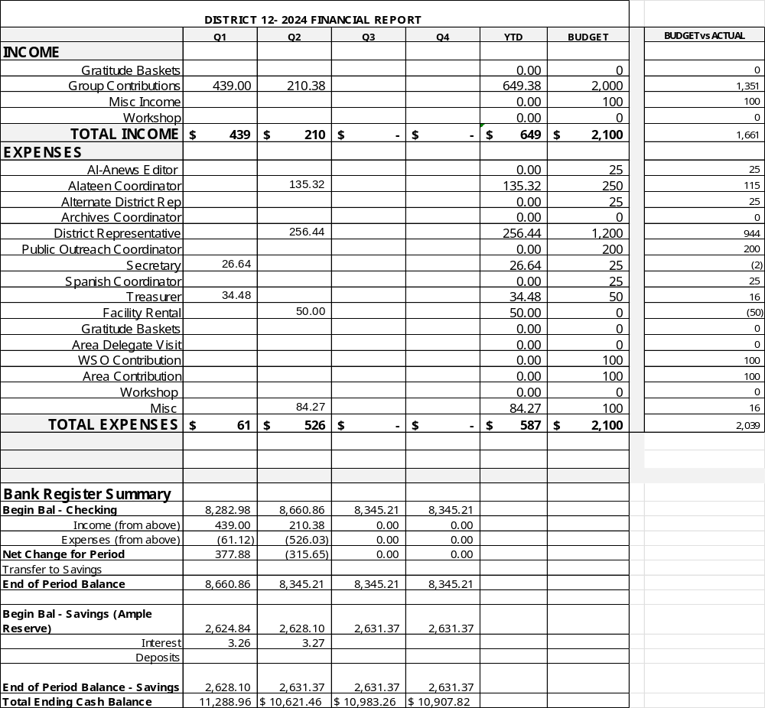

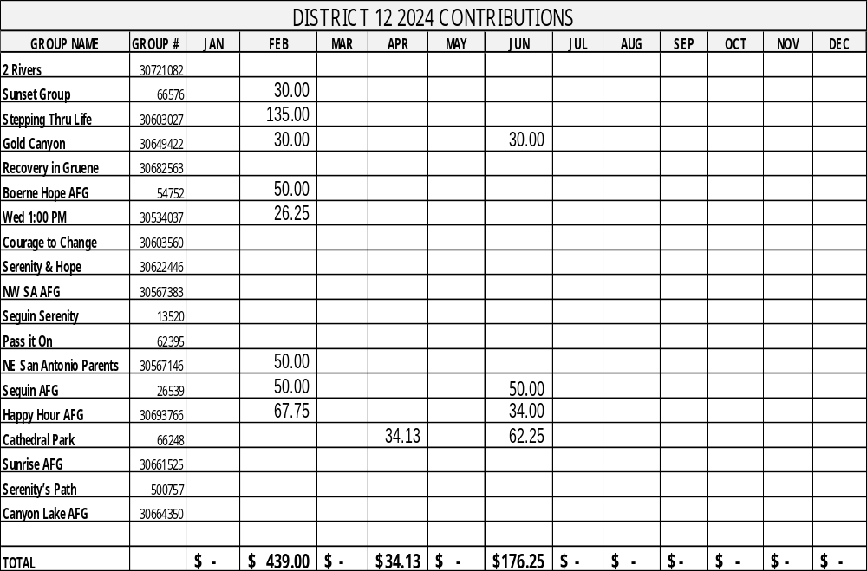

SERENITY CELEBRATION 2024

Final Preparation for Serenity Celebration is in the works – a message from the 2024 Chair
Serenity Celebration 09/08/24 – Cana Ballroom at 202 W. Kronkosky St. Boerne, Texas 78006
4 to 8 p.m. (doors open at 3:30)

We need the following positions to be filled and supported – please contact Candy N. if you are interested or need more information. I can be reached at cneal@nealtx.com

Dessert Coordinator – Ask an Al-ANEWS flash to be sent out asking for dessert contributions and volunteers to be spots for the auction. Start calling previous contributors who haven’t already committed. List of prior contributors is available. Ask contributors to provide their name and a description of the dessert. Accept the desserts at the event. You (and your spotter team) should determine which desserts go in the Live Auction and the order in which they will be presented for auction. Provide the information to the auctioneer as they are made available.

Drink Coordinator – Inventory the supplies on hand and report to the chair the additional supplies that are necessary: paper coffee cups (suggest small cups), plastic tea and water cups, stirrers, creamer, packets of sugar & sweeteners. The caterer is making the coffee, both regular and double decaf. You will be responsible for the tea & water and for letting the caterer know when more coffee is needed. (The venue has an ice machine and most of the dispensers and urns needed for coffee, tea and water.). Ask for volunteers to assist you at the event.

Table Service Coordinator – the Youth Group from the church is going to be doing the service to the tables. We need someone to organize and direct them at the event. They are great kids and just need some direction. Make sure any special dietary meals are delivered to the proper attendees.

There will be one or two Zoom committee meetings, prior to the event to answer questions and assist you.

Thank you for considering this opportunity to make a positive impact at the 2024 Serenity Celebration. We look forward to having you on our team.

2024 Chair
Candy N.

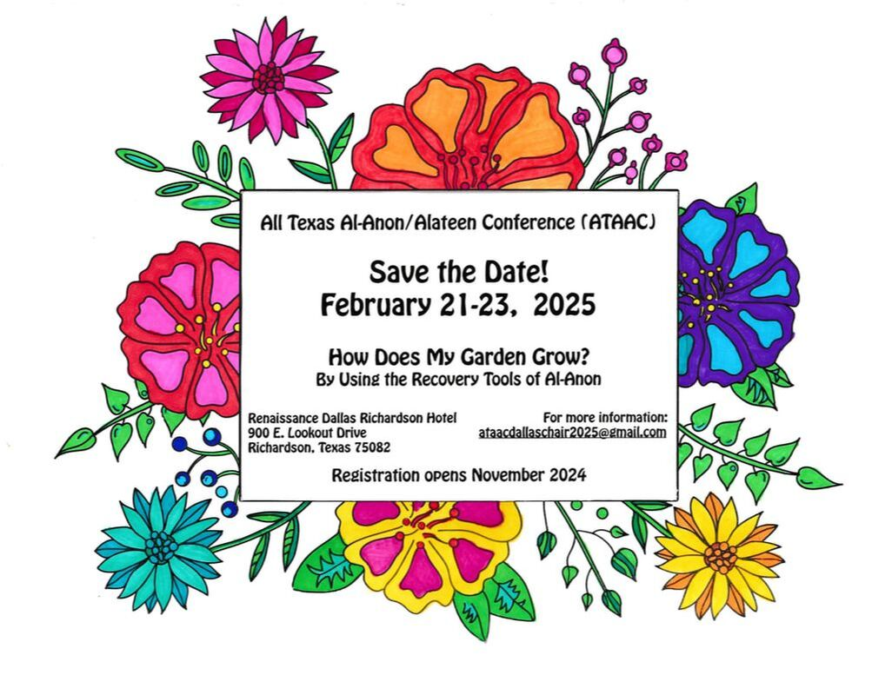
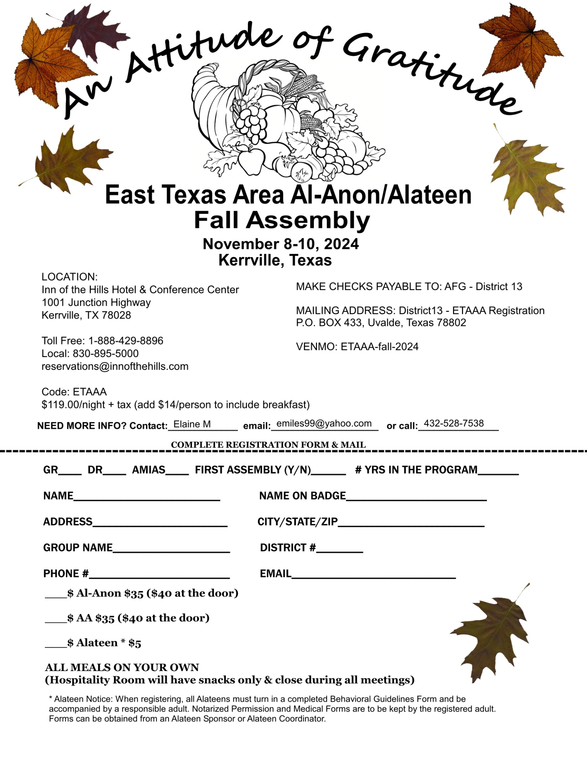

SAN ANTONIO AL-ANON INFORMATION SERVICE CONTRIBUTION
Make Check Payable to: SAAIS Mail to: SAAIS Treasurer
172 Fossil Hills Loop
Spring Branch, TX 78070
(address expires 12/31/2026)

Group Name _________________________________________District # _______ Group # _________

Current Mailing Address ________________________________________________________________

City/State/Zip_______________________________________________Telephone # ________________

Sent By ___________________________________Check # ______________ Amount ______________
TEXAS EAST AREA 53 CONTRIBUTION
Make Check Payable to: ETAAA-Treasurer Mail to: ETAAA
Attach this form to check or money order. PO Box 337
Do not send cash. Please print information. Pearland, TX 77588
(address expires 12/31/2026)

Group Name__________________________________________ District# ________ Group #__________

Current Mailing Address ________________________________________________________________

City/State/Zip _________________________________________Telephone # _____________________

Sent By ___________________________________ Check # ______________ Amount _____________

Email (for receipt) _______________________________________________________________________

DISTRICT 12 CONTRIBUTION
Make Check Payable to: AFG District 12 Mail to: District Treasurer
420 N Milam St
Seguin, TX 78155
(address expires 12/31/2026)

Group Name _________________________________________________ Group # _________________

Current Mailing Address ________________________________________________________________

City/State/Zip______________________________________________ Telephone # ________________

Sent By ___________________________________ Check # _____________ Amount _____________
AL-ANON WORLD SERVICE OFFICE CONTRIBUTION

Make Check Payable to: AFG, Inc. Mail to: AFG, Inc.
1600 Corporate Landing Pkwy
Virginia Beach, VA 23454-5617

Group Name ________________________________________District # _______ Group # _________

Current Mailing Address ______________________________________________________________

City/State/Zip_______________________________________________Telephone # ______________

Sent By _________________________________ Check # ______________ Amount ______________

